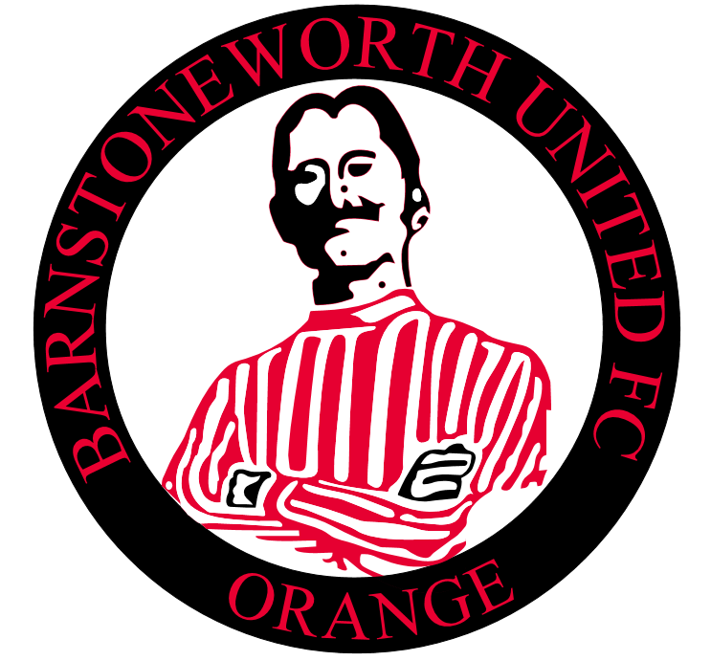

Barnstoneworth United Merchandise Catalogue
Order Form on Last Page
Club Polo Shirts – With Club & Nobby Logo =$30.00
Sizes; Small, Medium, Large, Extra Large, 2XL, 3XL
Red or White

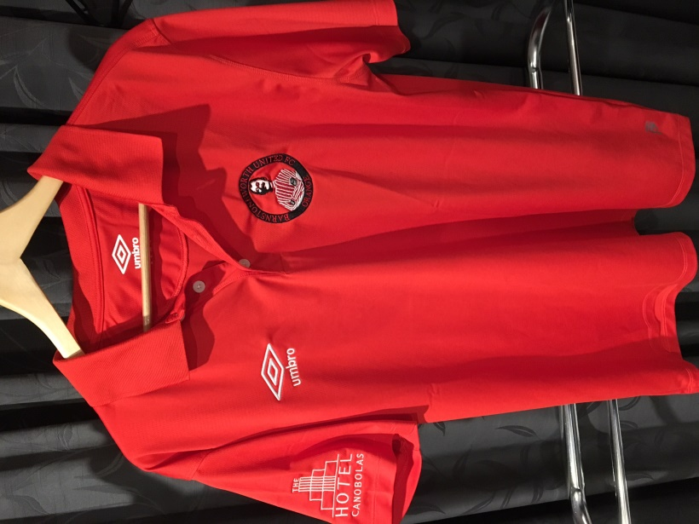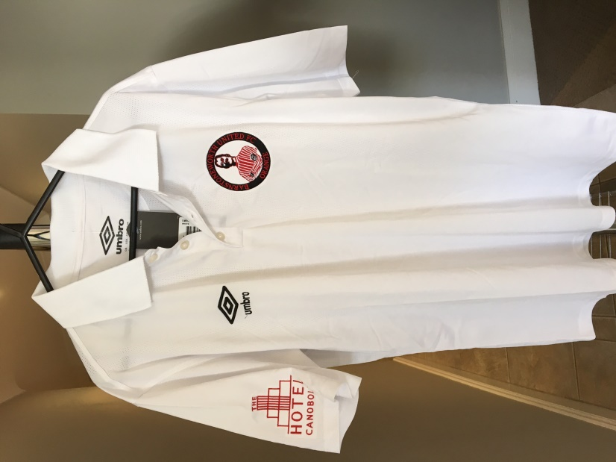

Club Playing Shorts =$15.00
Sizes; Small, Medium, Large, Extra Large, 2XL, 3XL
Colours
Denley – White
All Others teams - Black

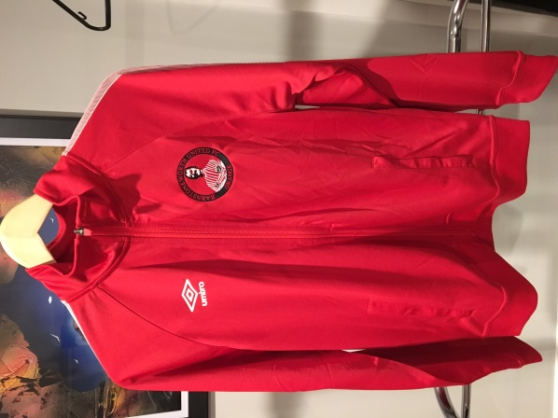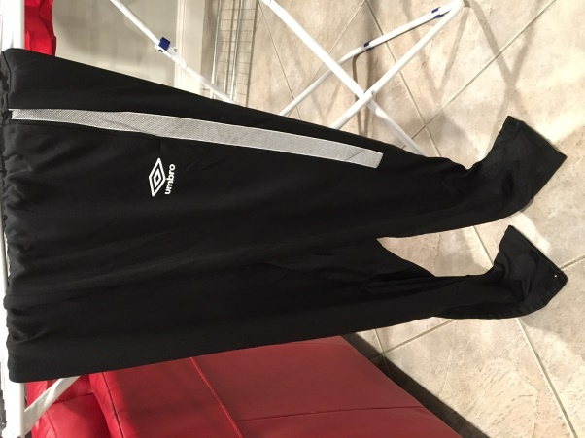
Club Tracksuit Set =$70.00
Sizes; Small, Medium, Large, Extra Large, 2XL, 3XL
Red/Black Only
Comes with Club Logo
Note: This is designed for training and is made from polyester and is not fleecy lined so may not be that warm in winter

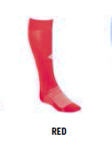
Club Socks =$8
Sizes; Mens 7-12 Only
Red/Black/Green

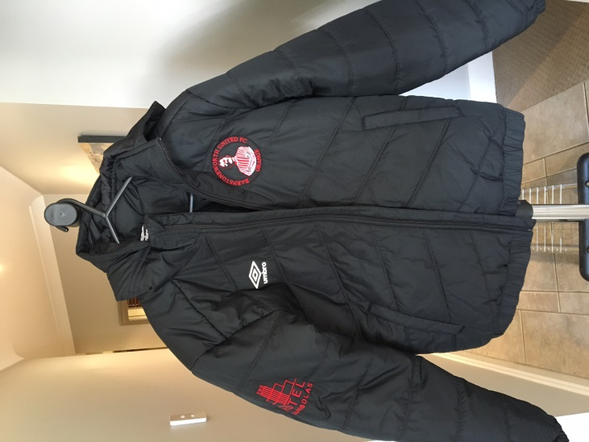
Club Bomber Jacket =$65.00
Sizes; Small, Medium, Large, Extra Large, 2XL, 3XL
Comes with Club & Nobby Logo
Black Only

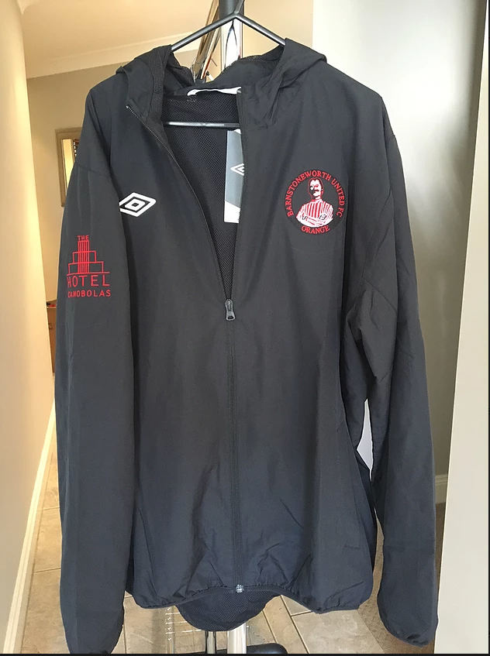
Club Spray Jacket =$40.00
Sizes; Small, Medium, Large, Extra Large, 2XL, 3XL
Comes with Club & Nobby Logo
Black Only

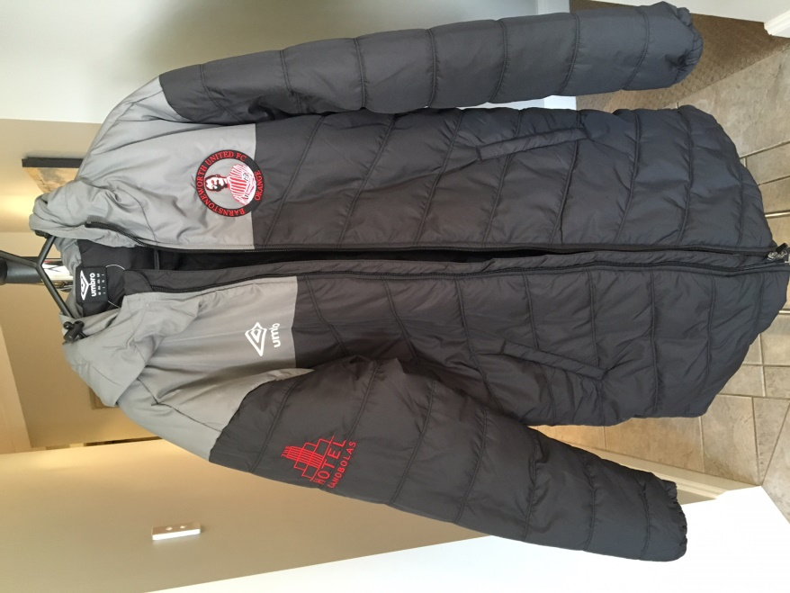
Long Club Coaches Jacket =$80.00
Sizes; Small, Medium, Large, Extra Large, 2XL, 3XL
Comes with Club & Nobby Logo
Black Only
(note lasts years model shown – these are all black now)

++NEW++
Wet Weather Jacket =$85.00
Sizes; Small, Medium, Large, Extra Large, 2XL, 3XL
Comes with Club & Nobby Logo
Black Only (Blue shown for demo)
These jackets are lined as well for warmth.

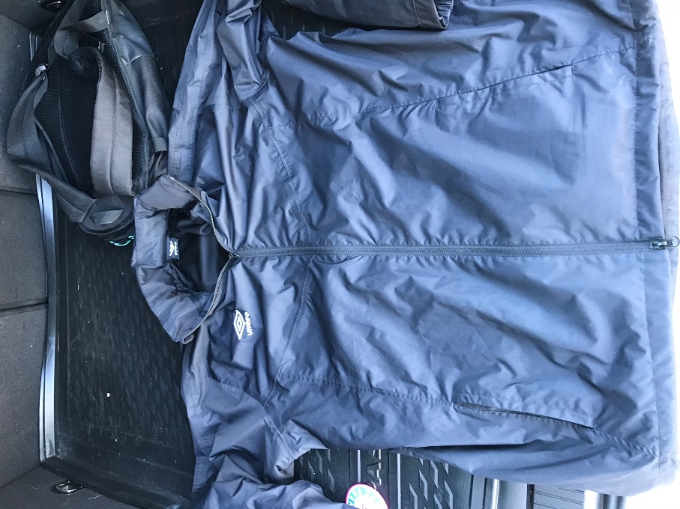

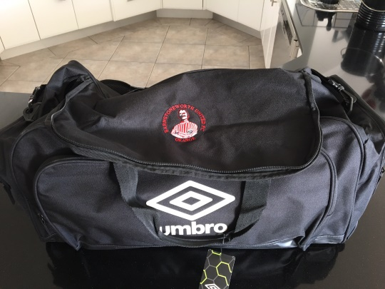
Small Club Bag =$30.00
Comes with Club & Nobby Logo
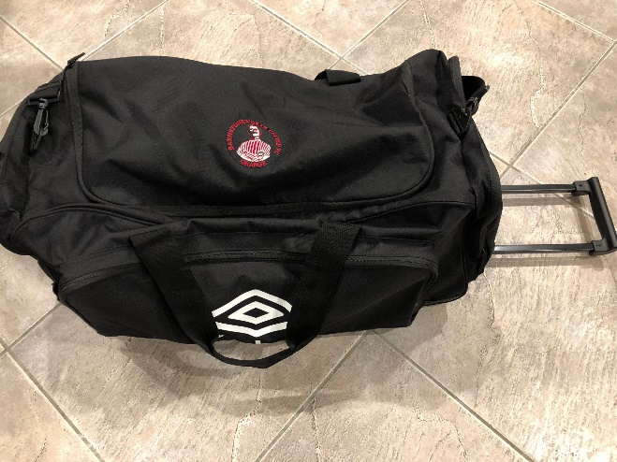
+++NEW+++
Large Club Bag (with wheels) =$55.00
Comes with Club & Nobby Logo

Barnstoneworth United Merchandise
Order Form
Name:
Contact Ph
How Paid | Direct Deposit | Cash
Please choose one

Item | Colour | Size | Cost
 |  |  | $
 |  |  | $
 |  |  | $
 |  |  | $
 |  |  | $
Amount Paid in Full |  |  | $

Direct Deposit Details
Barnstoneworth United Football Club
First Choice Credit Union
BSB - 802-318
Account – 40003397

